Proposal Report of CP on Bike Rental Service



Submitted by: Submitted to:

Prashant Shrestha Sir Sudeep Bajimaya

Batch- 22A

L5DC

NCC ID: 00174405

Contents

Introduction 4

Justification of the project 4

Features of the project 4

Overview of the project 4

2.Scope of the project 5

Scope 5

Limitation 5

Aim 5

Objectives 5

Overview of the scope 5

Chapter 3: Development Methodology 6

Description of Methodology 6

Advantages 7

Disadvantage 7

Design Pattern 7

Architecture 8

Advantage 8

Disadvantage 9

Chapter 4: Project Planning 10

WBS: 10

Milestone 11

Gantt chart 12

Chapter 5: Risk Management 14

Chapter 6: Configuration Management 15

Conclusion 17

References and Bibliography 18

Table of Figure

Figure 1: Waterfall Model .......................................................................................................................... 6

Figure 2: MVC design pattern .................................................................................................................. 7

Figure 3: Three-tier architecture .............................................................................................................. 9

Figure 4:WBS figure 1 ............................................................................................................................. 10

Figure 5: Gantt chart figure 1 ................................................................................................................. 12

Figure 6: Gantt chart figure 2 ................................................................................................................. 13 Figure 7: Directory Structure for Project ............................................................................................... 16

# Introduction

A rental service is a service in which customer request to hire a rental unit. It is more convenient and easier for the people who are new to the city for renting rather than buying a new one. Since by allocating the data of user who want to rent, **Eagles Bike Renting company** has made a platform where user can book and rents an automobile for short period of the time via their website. There will be various

## Justification of the project

There is not enough bike rental service which give the customer complete satisfaction so I choose this project as the customer can get the complete satisfaction through our service. Since this project will focus on customer our service will fully automated and online so that customers do not need to visit the nearest office.

## Features of the project

The main features of the project will be:

* There will be online transaction.
* Deliver location and pickup location for the customer.
* Booking system.
* Pickup date and deliver date.
* Information of the bikes.
* Invoice can be generated.

## Overview of the project

Eagles Bike Renting Company is a web application where users can book the bike and pay through the online.

# 2.Scope of the project

## Scope

this project deals with the online service of the rental service which are found in Nepal. The project scope is made to make online booking of the automobiles.

## Limitation

Though the project is being developed with no error, there are some limitations. Some of are:

* The renting service will be in limited area.
* Difficult to verify the bike whether it is genuine or theft.
* There will be no international transaction.

## Aim

The aims of this project are:

* To make the user satisfaction through our service.
* Making booking easier and whole system automated.
* To provide smooth transaction for the customer.
* To maintain secure system

## Objectives

The project has many aims and goals so to attain all the goals I have to follow various objectives. Some of them are:

* Providing the condition bike for the customer.
* Making user friendly and easy to use system.
* Easy searching of the automobiles.
* Invoice generation after successful transactions.
* Providing the detailed information of the bikes.
* Making booking and transaction automated.

## Overview of the scope

This project behaves as a market which gives a platform for the customer to rent a automobiles service. The main aim of the system is to make user satisfaction through our services.

# Chapter 3: Development Methodology

## Description of Methodology

There is various methodology to make the system. For my system I have approached the waterfall model which is easy and feasible for making the system. It contains 6 steps that should be followed while making a program. The 6 steps are:

* Planning

In this phase there will be a group discussion how the system should be made and a plan we should follow.

* Analysis

In this phase the group will analyze how the system will perform in long-term basis and how it will benefit.

* Design

In this phase the system design is prepared. As the system design will helps in specifying hardware and system requirements which will help in overall system architecture.

* Implementation

In this phase the source code is developed using the models, logic and requirements designated in the prior stage. This is the vital phase as the simple mistake will make the problem in system.

* Testing

In this phase there will be quality, assurance, unit, system and beta test take place to report issues that may need to be resolved. This may cause a forced repeat of the coding stage for debugging.

* Deployment and Maintenance

In this phase the system is deployed to the general public as a beta product and if there is no bug then the system will be deployed. After the deployment there will be a maintenance of the product so that if there will be any issues or problem which should be fixed or enhanced is should be taken care by the developers.

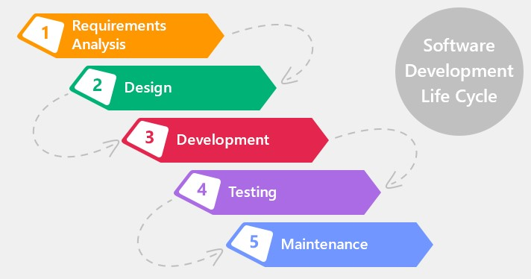

*Figure 1: Waterfall Model*

## Advantages

The advantages of the waterfall model are:

* It is easy and simple to use for the learners
* It clearly defines the milestones and deadlines.
* It allows the early design or specification changes to be made easily.
* Reinforces good coding habits to define before design and then code.

## Disadvantage

The disadvantages of the waterfall model are:

* It is not suitable for the large projects.
* Does not handle request for changes, scope adjustments or updates well.
* Reduces efficiency by not allowing processes to overlap.
* No working product is available until the later stages of the life cycle.

## Design Pattern

There is various design pattern which can be followed during a system making. Some of the design pattern are MVC (Model View Controller), DOA, etc. I have used the MVC design pattern as it is easy to use and follow.

* **Model**

Model represents an object or JAVA POJO carrying data. It can also have logic to update controller if its data changes.

* **View** - View represents the visualization of the data that model contains.
* **Controller** - Controller acts on both model and view. It controls the data flow into model object and updates the view whenever data changes. It keeps view and model separate.

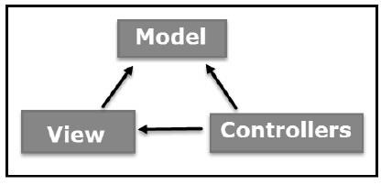

*Figure 2: MVC design pattern*

## Advantages of MVC:

• It helps in the rapid development of an application. Here one of the programmers can work on view while the other one can work on controller.

• There is a minimal chance of code duplication in this method as it separates data and business logic from the display • It supports asynchronous technique which helps to develop an application that loads very fast.

• Modification does not affect the entire model because model part does not depend on the views part.

## Disadvantages of MVC:

• It increases the complexity of the application.

• Multiple programmers are needed.

• Developers must have knowledge on multiple technologies.

• There is shortage of efficiency of data access in view.

The tools that I will use in this project are:

|  |  |
| --- | --- |
| Programming Paradigm | Object Oriented |
| Server Solution Stack | XAMPP |
| Modelling Tool | Visual Paradigm |
| Framework | Laravel |
| Programming language | PHP |
| Database | MySQL |

## Architecture

For this project I have followed 3-tier architecture pattern. A 3-tier architecture is a client-server architecture in which the functional process logic, data access, computer data storage and user interface are developed and maintained as independent modules on separate platforms.3-tier architecture is a software design pattern and a well-established software architecture.

The three tiers in a three-tier architecture are:

1. Presentation Tier: Occupies the top level and displays information related to services available on a website. This tier communicates with other tiers by sending results to the browser and other tiers in the network.
2. Application Tier: Also called the middle tier, logic tier, business logic or logic tier, this tier is pulled from the presentation tier. It controls application functionality by performing detailed processing.
3. Data Tier: Houses database servers where information is stored and retrieved. Data in this tier is kept independent of application servers or business logic.

## Advantage

The advantages of the 3-tier architecture are:

* Complex application rules easy to implement in application server
* Business logic off-loaded from database server and client, which improves performance.
* Superior performance for medium to high volume environments.
* Application server logic is portable to other database server platforms by virtue of the application software.

## Disadvantage

The disadvantages of the 3-tier architecture are:

* More complex structure.
* More difficult to setup and maintain.
* The physical separation of application servers containing business logic functions and database servers containing databases may moderately affect performance.

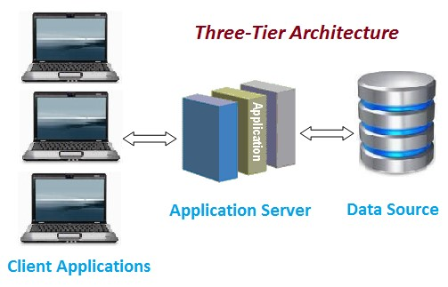

*Figure 3: Three-tier architecture*

# Chapter 4: Project Planning

## WBS:

Dividing complex projects to simpler and manageable tasks is the process identified as Work Breakdown Structure (WBS). Usually, the project managers use this method for simplifying the project execution. In WBS, much larger tasks are broken down to manageable chunks of work. These chunks can be easily supervised and estimated. WBS is not restricted to a specific field when it comes to application. This methodology can be used for any type of project management.

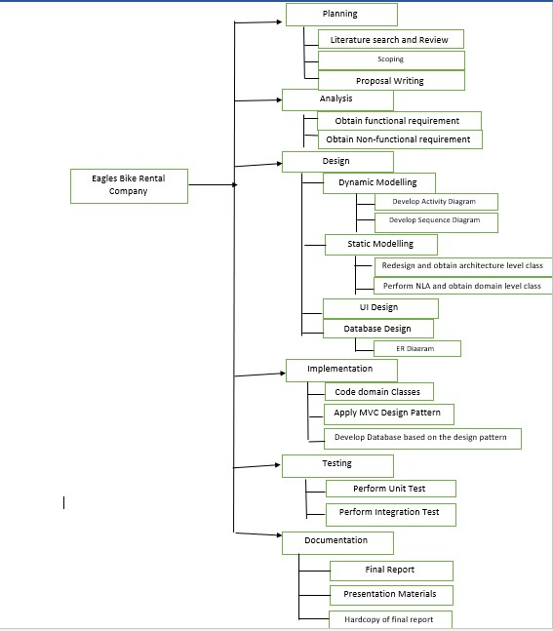

*Figure 4:WBS figure 1*

|  |  |  |
| --- | --- | --- |
| WBS | Task Name | Estimate  Time  (Days) |
| 0. | Project-Eagles Bike Renting Service | 109 |
| 1. | **Planning** | **15** |
| 1.1. | Literature Search and Review | 2 |
| 1.2. | Scoping | 3 |
| 1.3. | Proposal Writing | 10 |
| 2. | **Analysis** | **29** |
| 2.1. | Obtain Functional Requirement | 14 |
| 2.2. | Obtain Non-functional Requirement | 15 |
| 3. | **Design** | **26** |
| 3.1. | Dynamic Modelling | 5 |
| 3.2. | Static Modelling | 6 |
| 3.3. | UI Design | 10 |
| 3.4 | Database Design | 5 |
| 4. | **Implementation** | **21** |
| 4.1. | Code Domain Classes | 6 |
| 4.2. | Apply MVC pattern | 9 |
| 4.3. | Develop Database based on Design Pattern | 6 |
| 5. | **Testing** | **7** |
| 5.1. | Perform Unit Testing | 4 |
| 5.2. | Perform Integration Testing | 3 |
| 6. | **Documentation** | **11** |
| 6.1 | Final Report | 5 |
| 6.2. | Presentation Materials | 5 |
| 6.3. | Hardcopy of final report | 1 |

For this project, I have taken 136 days where for planning I have allocated 28 days, for analysis

28 days, for design 25 days, for implementation 20 days, for testing 20 days and for documentation 15 days.

## 

## Milestone

The milestone for this project is briefly given in the table below with the start date and with their corresponding deadlines.

|  |  |  |
| --- | --- | --- |
| Topic | Start Date | Deadline |
| Proposal | 26th March 2019 | 9th April 2019 |
| Literature Search and Review | 26th March 2019 | 27th March 2019 |
| Scoping | 29th March 2019 | 31th March 2019 |
| Proposal Writing | 31th March 2019 | 9th April 2019 |
| Analysis | 10th April 2019 | 8th May 2019 |
| Obtain Functional Requirement | 10th April 2019 | 23th April 2019 |
| Obtain Non-functional Requirement | 24th April 2019 | 8th May 2019 |
| Design | 9th May 2019 | 3rd June 2019 |
| Dynamic Modelling | 9th May 2019 | 13th May 2019 |
| Static Modelling | 15th May 2019 | 20th May 2019 |
| UI Design | 21th May 2019 | 30th May 2019 |
| DB Design | 31th May 2019 | 3rd June 2019 |
| Implementation (Coding) | 4th June 2019 | 24th June 2019 |
| Code Domain Classes | 4th June 2019 | 9th June 2019 |
| Apply MVC pattern | 10th June 2019 | 19th June 2019 |
| Develop Database based on Design Pattern | 20th June 2019 | 24th June 2019 |
| Testing | 25th June 2019 | 1st July 2019 |
| Perform Unit Testing | 25th June 2019 | 28th June 2019 |
| Perform Integration Testing | 29th June2019 | 1st July 2019 |
| Final Doc | 2nd July 2019 | 12th July 2019 |
| Final Report | 2nd July 2019 | 6th July 2019 |
| Presentation Materials | 7th July 2019 | 10th July 2019 |
| Hardcopy of final report | 11th July 2019 | 12th July 2019 |

## Gantt chart

A Gantt chart, commonly used in project management, is one of the most popular and useful ways of showing activities (tasks or events) displayed against time. On the left of the chart is a list of the activities and along the top is a suitable time scale. Each activity is represented by a bar; the position and length of the bar reflects the start date, duration and end date of the activity.

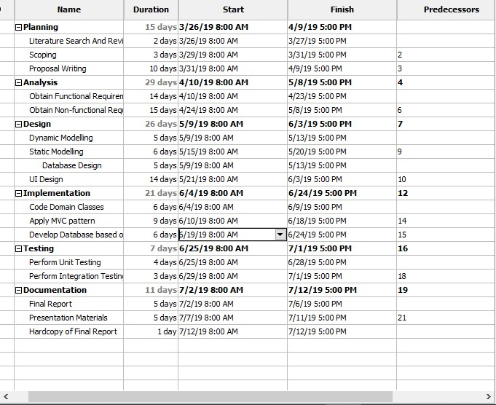

*Figure 5: Gantt chart figure 1*

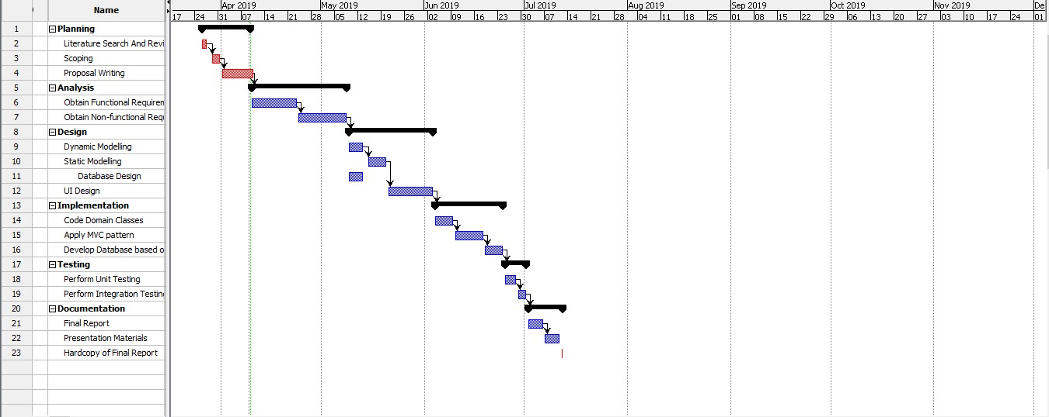

*Figure 6: Gantt chart figure 2*

# Chapter 5: Risk Management

Risk management is the process of identifying, assessing and controlling threats to an organization's capital and earnings. These threats, or risks, could stem from a wide variety of sources, including financial uncertainty, legal liabilities, strategic management errors, accidents and natural disasters. IT security threats and data-related risks, and the risk management strategies to alleviate them, have become a top priority for digitized companies.

For the risk management its most to find the risks that can damage the system. The steps that we can follow for risk management are:

1. Identify risk
2. Access impact of risk
3. Alleviate critical risk
4. Control risk

We follow the following two table to calculate the impact of the risk.

|  |  |
| --- | --- |
| Likelihood | Value |
| Low | 1 |
| Medium | 2 |
| High | 3 |

|  |  |
| --- | --- |
| Consequences | Value |
| Very Low | 1 |
| Low | 2 |
| Medium | 3 |
| High | 4 |
| Very high | 5 |

Taking this value, we can calculate the risk management as Impact = Likelihood x Consequences

The table containing the risk management is given below:

|  |  |  |  |  |  |  |
| --- | --- | --- | --- | --- | --- | --- |
| Risk Type | Risk | Likelihood | Consequence  s | Impact | Action type | Action |
| Nontechnical | Natural Disaster | 2 | 4 | 8 | Contingency | Regular backup of data to prevent any data loss |
|  | Deadline  Overruns | 2 | 4 | 8 | Avoidance | Keeping tabs of the  time so that  the work will be  completed before the deadline |
| Increasing the growth of the project which causes the project to go over the budget | 2 | 3 | 6 | Avoidance | Thorough planning of the requirement specificatio n of the project |
| Technic  al | Technical  difficulty  during design  and implementatio  n | 2 | 3 | 6 | Deflection | Getting advice from superior and other faculty  member to prevent any difficulty. |
| Hardware  failure | 2 | 3 | 6 | Avoidance | Proper maintenanc  e of hardware to prevent any issues |
| Hard disk failure | 3 | 5 | 15 | Contingenc  y | Cloning the hard disk before starting any project. |

Here are some solutions for the risk that have high impacts:

1. Following the proper procedure to minimize the risks.
2. Proper backup of data to prevent data loss
3. Following the timetable in a proper order to finish the project in time.

# Chapter 6: Configuration Management

The project is based on the SDLC or waterfall model so it has directory that is based on this model. Each phase has its own folder and contain its own files. The final project directory contains the following folder in it:

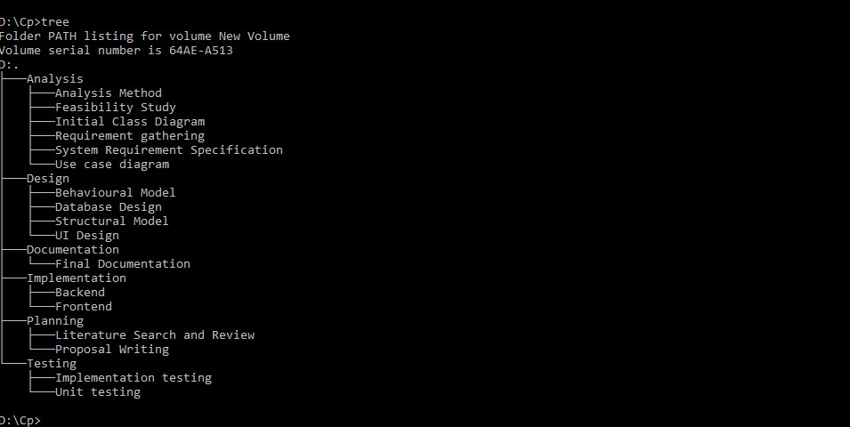

*Figure 7: Directory Structure for Project*

Analysis folder contain other folder such as analysis method, feasibility study, initial class diagram, requirement gathering, system requirement specification and use case diagram.

Design folder contain folder such as behavioral model, structural model and UI design. Implementation folder contain folder such as backend and frontend. Testing folder contains folder such as implementation testing and unit testing. Planning folder contains folder such as literature search and review and proposal writing. Documentation folder contain final documentation.

# Conclusion

Eagles bike rental company is an online service which helps the customer to rent the automobiles. There are many features such as customer can pay through online via the websites which will be easier to the customer. To make this project I have used PHP and MY SQL and MVC design pattern. In this way this project will be made to give a platform for customer to rent easily.

# References and Bibliography

Rahman, S. (2016). Design pattern: Obligation link design pattern. Beaumont, TX: Lamar University.

1. Siegel, J. G., & Shim, J. K. (2003). The managers handbook of client/server computing in business and finance. Mason, OH: Thomson/South-Western.

1. Metsker, S. J. (2002). Design patterns Java workbook. Boston: AddisonWesley